Experiment 2
A:
Code:
public class Main {
public static void main(String[] args) {

int seed = 3;
int a = 5;
int c = 2;
int m = 13;
int n = 5;

int[] sequence = new int[n + 1];
sequence[0] = seed;

int x = seed;

System.out.println("Linear Congruential Generator");
System.out.println("------------------------------");

for (int i = 1; i <= n; i++) {
x = (a * x + c) % m;
sequence[i] = x;
System.out.println(x);
}

System.out.print("\nGenerated Sequence: ");

for (int i = 0; i <= n; i++) {
System.out.print(sequence[i] + " ");
}
}
}
Output:
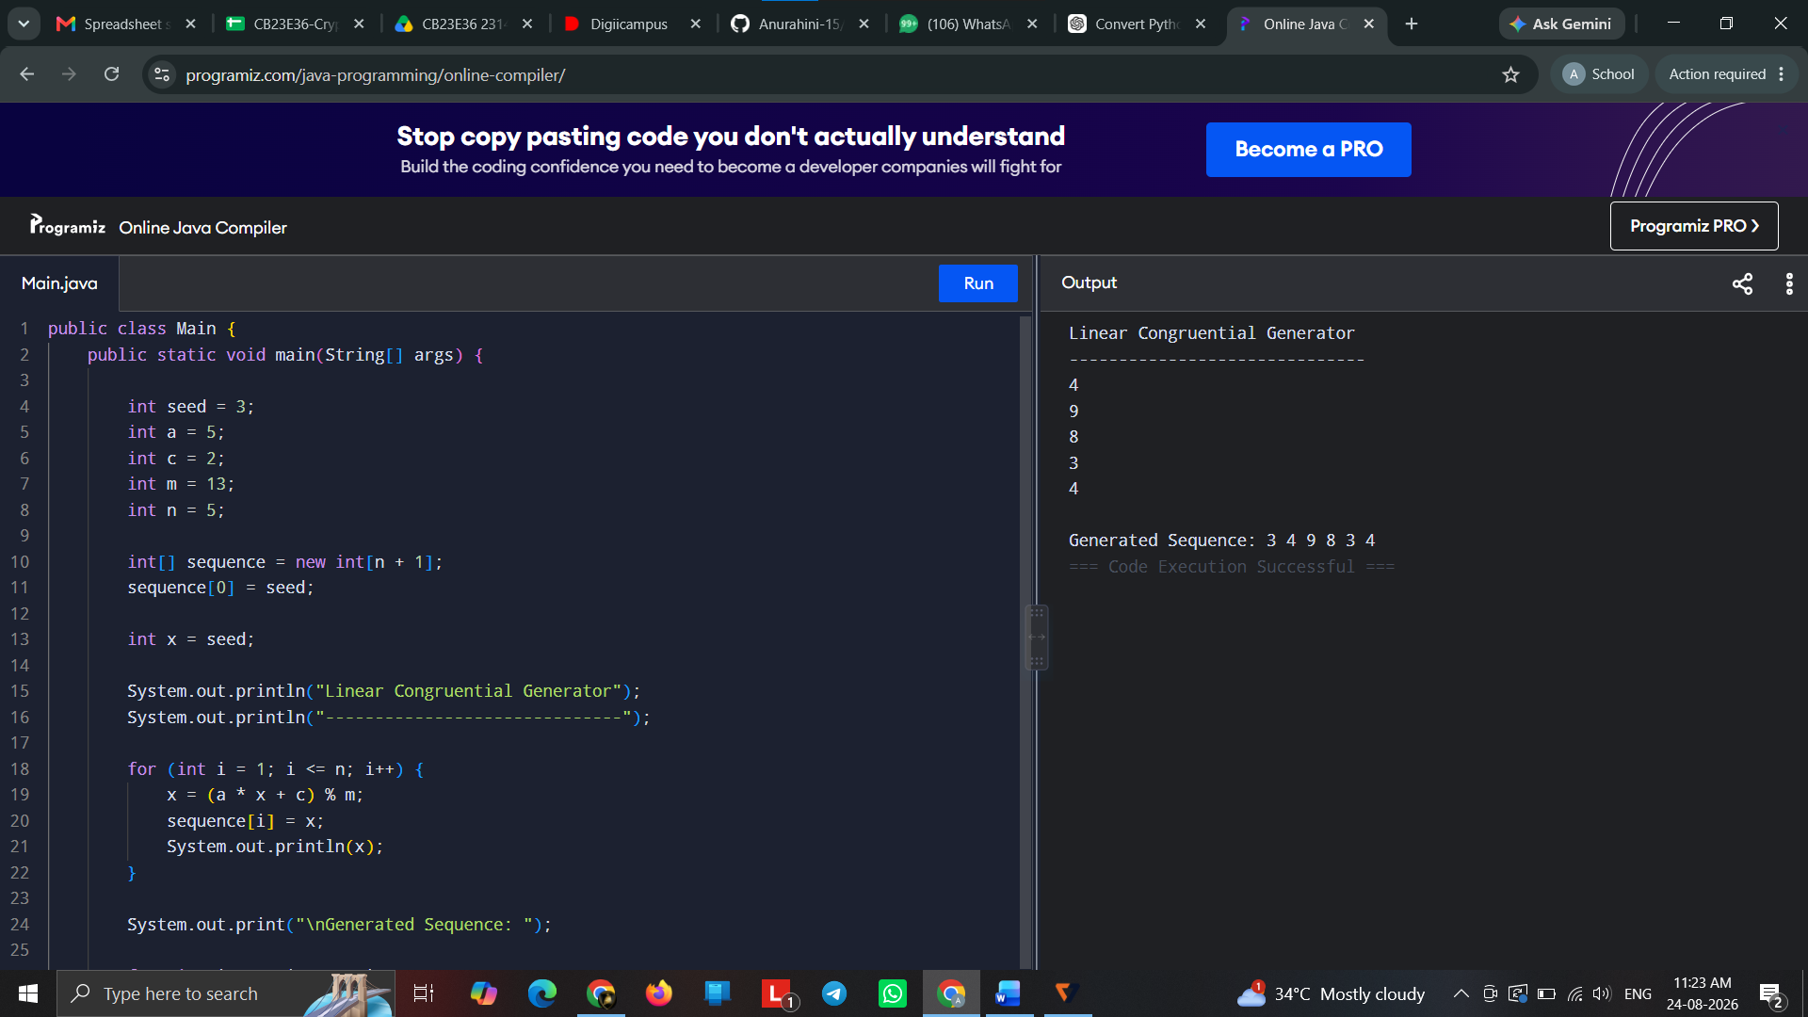

B:
Code:
public class Main {
public static void main(String[] args) {

int p = 7, q = 11, seed = 16, numBits = 5;
int n = p * q;

if (seed % n == 0) {
System.out.println("Invalid seed");
return;
}

int x = seed;
String bits = "";

System.out.println("Blum Blum Shub Generator");
System.out.println("------------------------");

for (int i = 0; i < numBits; i++) {
x = (x * x) % n;
int bit = x % 2;

bits = bits + bit;

System.out.println("Random number = " + x + " Output bit = " + bit);
}

System.out.println("\nBit stream = " + bits);
}
}
Output:
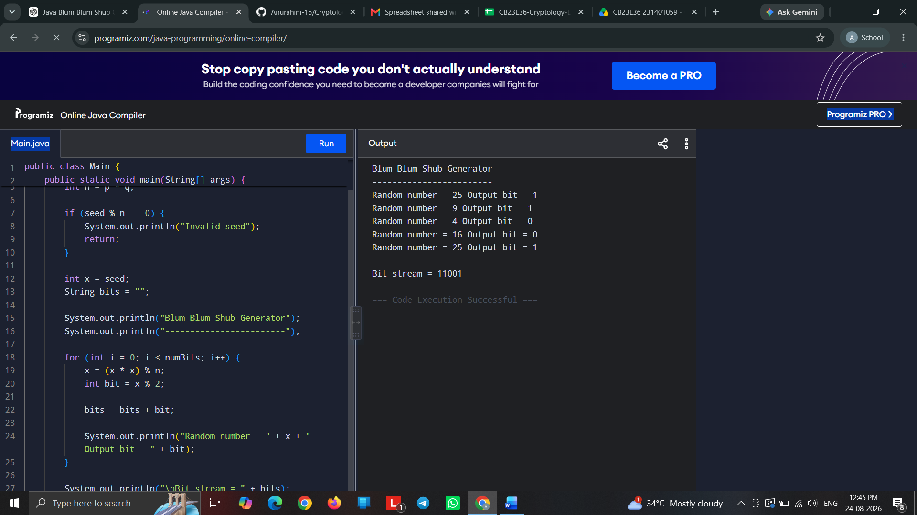

C
Code:
public class Main {
public static void main(String[] args) {

int[] register = {1, 0, 1, 1};
int n = 10;

System.out.println("Linear Feedback Shift Register");
System.out.println("------------------------------");

for (int i = 0; i < n; i++) {

int feedback = register[0] ^ register[3];
int output = register[3];

register[3] = register[2];
register[2] = register[1];
register[1] = register[0];
register[0] = feedback;

System.out.println("Step " + (i + 1));
System.out.println("Feedback = " + feedback);
System.out.println("Output = " + output);

System.out.print("Register = ");
for (int j = 0; j < 4; j++) {
System.out.print(register[j] + " ");
}

System.out.println("\n");
}
}
}
Output:
